PREDICTIONS & BUSINESS INSIGHTS REPORT
LA Fitness Expansion Strategy
Regression Results, Scenario Pricing, and Florida Market Priorities
All 67 Florida counties | Census + Google Places | OLS regression
Prepared for the MSIS Data Science Assignment | August 29, 2026

Observed demographic and location data; transparently estimated membership-price target

Executive Summary
The analysis combines observed Census demographics with 387 Google Places records across 67 Florida counties. The full six-variable OLS model explains 57.3% of variation in the estimated price target; the refined model retains LAFitnessLocations, MedianHouseholdIncome, PopulationDensity, AvgGymRating and achieves adjusted R-squared of 0.539.
Recommendation: Prioritize validation in Broward County, then St. Johns County, Miami-Dade County, Orange County, and Palm Beach County. These are screening priorities, not final real-estate decisions.

Decision boundary: The membership-price target is estimated, so coefficient significance and county rankings demonstrate an analytical workflow rather than independently verified economics. Do not commit capital until actual club pricing, leases, trade-area demographics, traffic, and competitor capacity are validated.

Data and Modeling Approach
- Unit of analysis: one row per Florida county (n = 67).
- Dependent variable: estimated average monthly MembershipPrice in U.S. dollars.
- Independent variables: population, LA Fitness count, competitor count, household income, density, and average rating.
- Observed location data: live Google Places Text Search results, exact-county filtered and deduplicated by Place ID.
- Estimation method: Ordinary Least Squares using Python statsmodels.
Where direct county pricing was unavailable, the assignment permits simulated data. The price target uses a documented teaching formula anchored to public chain and industry price points, plus normally distributed noise. The formula was clipped to $24-$55 per month and should not be interpreted as a survey:
Price = 8 + 0.0000015(Population) + 0.45(LA) - 0.12(Competitors) + 0.00012(Income) + 0.001(Density) + 5(Rating) + error

Full OLS Model
Metric | Full model | Refined model
R-squared | 0.573 | 0.567
Adjusted R-squared | 0.530 | 0.539
AIC | 314.92 | 311.85
BIC | 330.35 | 322.87
RMSE (USD) | $2.29 | $2.30

Variable | Coefficient | p-value | 95% confidence interval
Intercept | -0.810350 | 0.936 | [-20.7904, 19.1697]
CountyPopulation | 0.000001 | 0.774 | [-0.0000, 0.0000]
LAFitnessLocations | 0.527039 | 0.075 | [-0.0553, 1.1094]
CompetitorLocations | -0.143875 | 0.411 | [-0.4916, 0.2038]
MedianHouseholdIncome | 0.000095 | 0.001 | [0.0000, 0.0002]
PopulationDensity | 0.001835 | 0.024 | [0.0002, 0.0034]
AvgGymRating | 7.330552 | 0.002 | [2.8241, 11.8370]

Multicollinearity
Variable | VIF | VIF > 5 assessment
CountyPopulation | 19.27 | Concern
LAFitnessLocations | 9.71 | Concern
CompetitorLocations | 15.70 | Concern
MedianHouseholdIncome | 1.25 | Acceptable
PopulationDensity | 2.36 | Acceptable
AvgGymRating | 1.05 | Acceptable

The highest VIF is 19.27 for CountyPopulation. Values above 5 are flagged because correlated market-size measures can make individual coefficients unstable even when overall fit is useful.

Refined Model
Backward elimination removed variables with p-values above 0.05, one at a time. Removed variables: CountyPopulation, CompetitorLocations. This mechanical rule was used for the assignment demonstration; real strategy work should also preserve variables supported by business theory.
Variable | Coefficient | p-value | 95% confidence interval
Intercept | -0.172449 | 0.986 | [-19.7505, 19.4056]
LAFitnessLocations | 0.384059 | 0.006 | [0.1147, 0.6534]
MedianHouseholdIncome | 0.000088 | 0.002 | [0.0000, 0.0001]
PopulationDensity | 0.001670 | 0.032 | [0.0001, 0.0032]
AvgGymRating | 7.246642 | 0.002 | [2.8207, 11.6726]

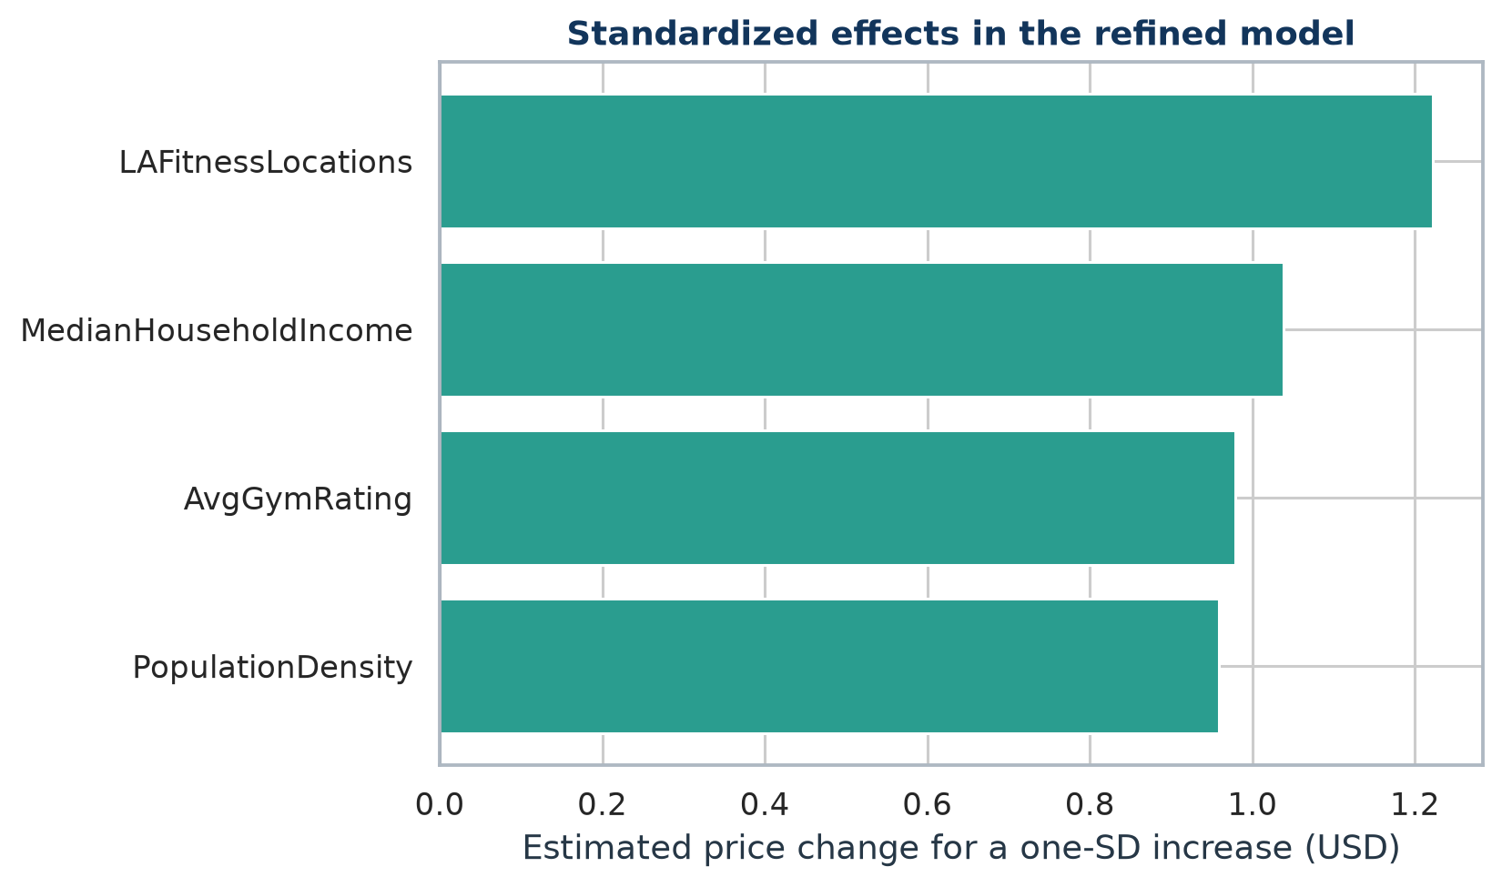
Figure 1. Refined-model price effect associated with a one-standard-deviation increase in each retained predictor.

Interpretation
- Strongest retained factor: LAFitnessLocations has the largest absolute one-standard-deviation effect ($1.22).
- Competition: the full-model coefficient is -0.144 dollars per additional tracked competitor (p = 0.411). It was removed during refinement, so the analysis does not establish an independent competition effect after controlling for the other predictors.
- All interpretations are associations within an estimated teaching target, not causal effects.

Model Diagnostics
Diagnostic test | Statistic | p-value | Interpretation
Shapiro-Wilk residual normality | 0.965 | 0.055 | No evidence against normality
Breusch-Pagan homoscedasticity | 1.458 | 0.834 | No evidence of heteroscedasticity
Breusch-Pagan F version | 0.345 | 0.847 | No evidence of heteroscedasticity

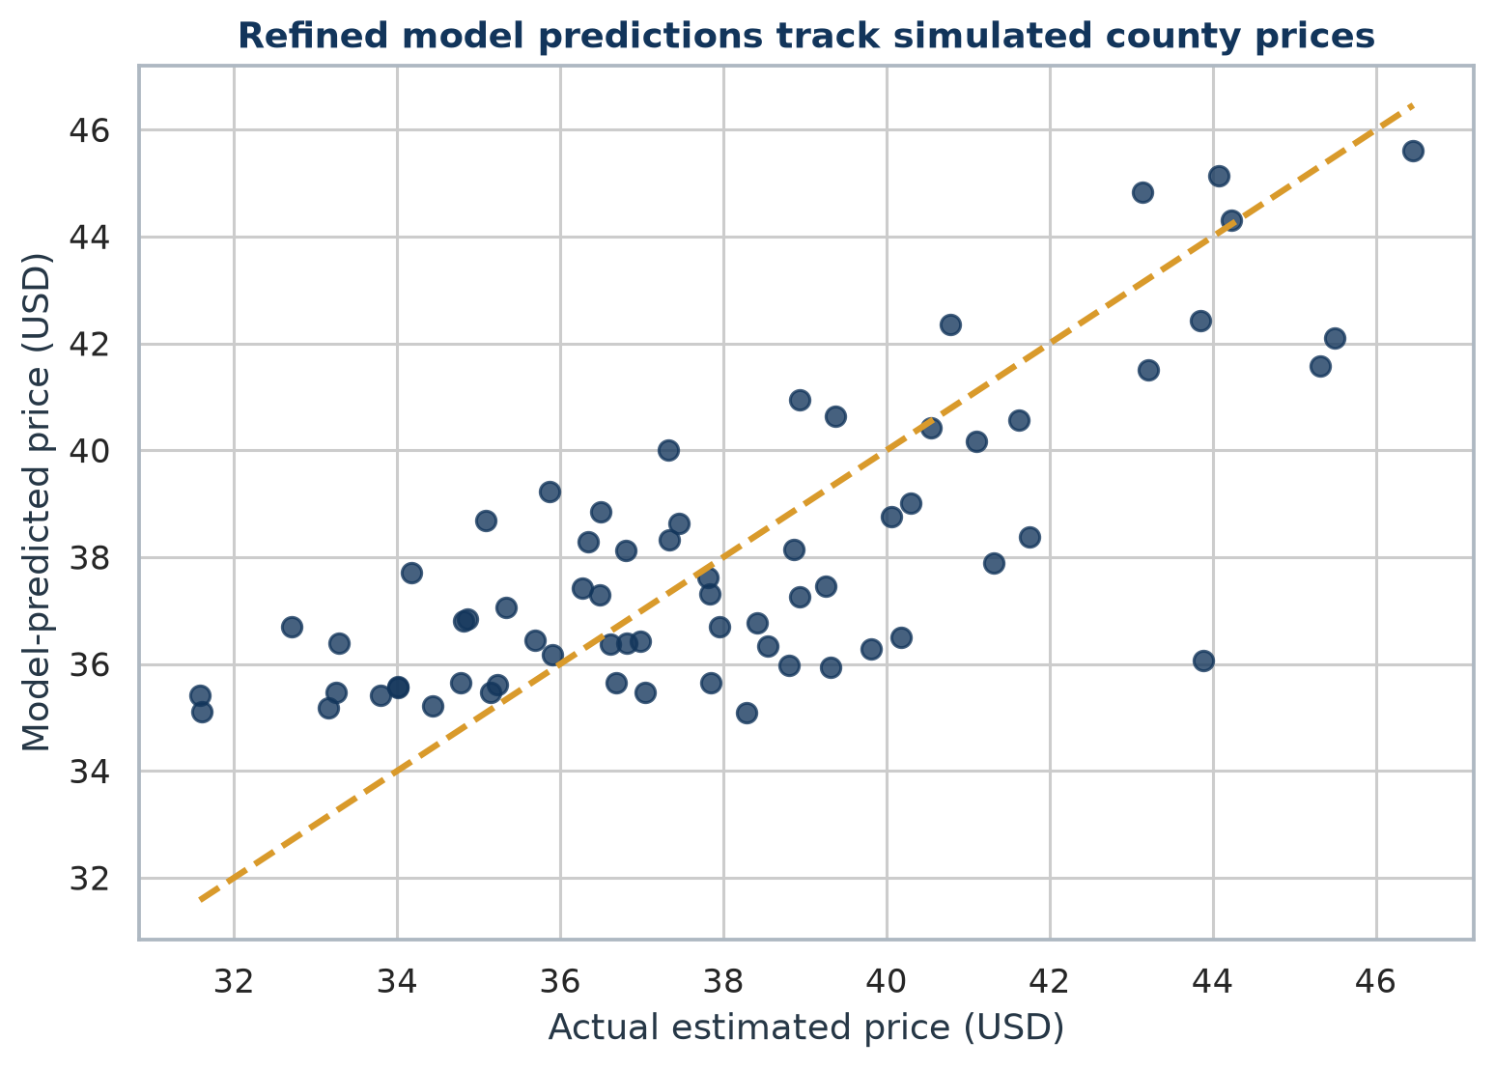
Figure 2. Actual estimated prices versus refined-model predictions.
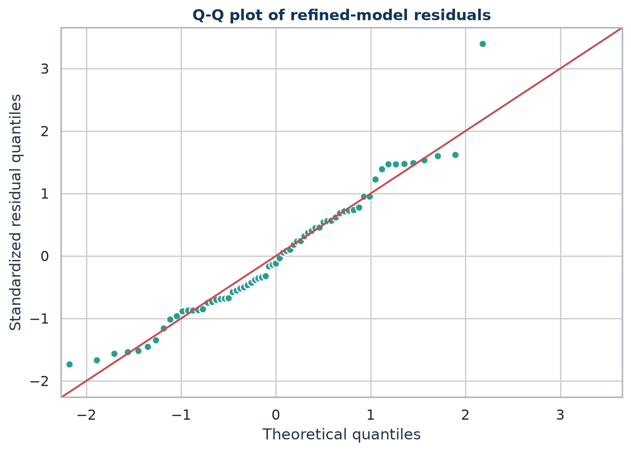
Figure 3. Q-Q plot of refined-model residuals.
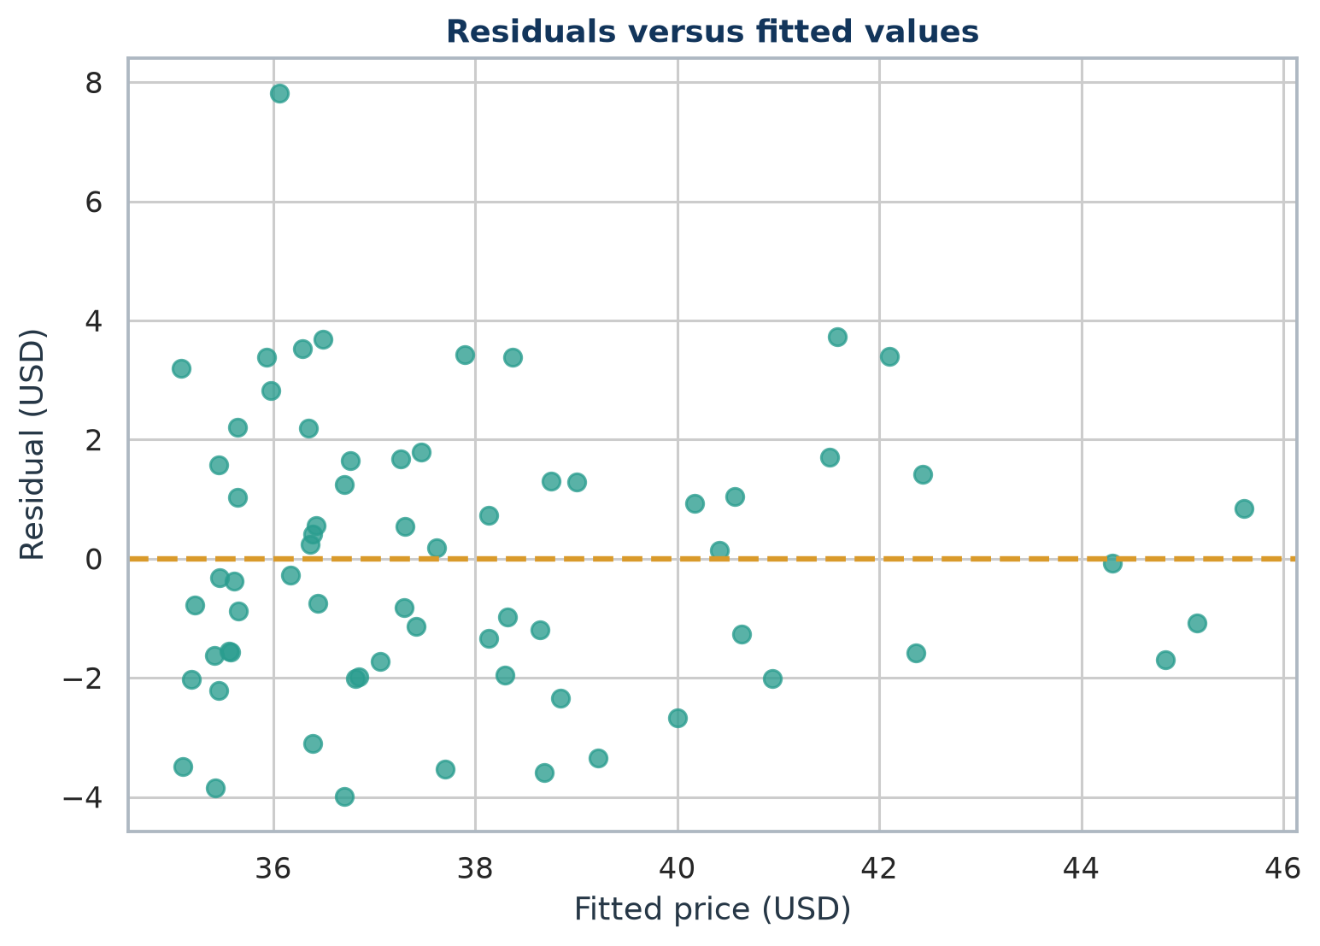
Figure 4. Refined-model residuals versus fitted values.

Influential Observations
County | Studentized residual | Cook's distance | Leverage
Pinellas County | 0.59 | 0.129 | 0.645
Miami-Dade County | -0.93 | 0.123 | 0.417
St. Johns County | 1.59 | 0.107 | 0.179
Columbia County | 3.62 | 0.055 | 0.025

Scenario Predictions
Each scenario supplies every variable in the original full model. Predictions use the refined model. The mean confidence interval describes uncertainty in the expected county price; the wider prediction interval describes uncertainty for a single comparable county outcome.
Scenario | Predicted price | 95% mean CI | 95% prediction interval
A - Rural, low competition | $36.69 | $35.36 - $38.02 | $31.72 - $41.65
B - Miami-Dade, high competition | $44.45 | $41.61 - $47.30 | $38.89 - $50.02
C - Target market: Broward County | $45.14 | $42.84 - $47.44 | $39.84 - $50.45

A - Rural, low competition
Population 50,000; LA Fitness locations 2; competitors 1; median household income $62,000; density 120.0 per square mile; average rating 4.20.

B - Miami-Dade, high competition
Population 2,600,000; LA Fitness locations 15; competitors 30; median household income $57,815; density 1,422.1 per square mile; average rating 4.33.

C - Target market: Broward County
Population 1,944,375; LA Fitness locations 13; competitors 27; median household income $64,522; density 1,616.6 per square mile; average rating 4.41.

Expansion Recommendations
The market-potential score is a transparent screening index calculated within this 67-county dataset. Weights are 30% demand (log population), 25% purchasing power, 20% low competitor intensity, 15% predicted price, and 10% low LA Fitness intensity. Components are min-max normalized, so the score is relative and not transferable to another state or vintage without recalculation.
Rank | County | Score | Population | Median income | Predicted price
1 | Broward County | 78.4 | 1,944,375 | $64,522 | $45.14
2 | St. Johns County | 77.9 | 273,425 | $88,794 | $42.10
3 | Miami-Dade County | 77.8 | 2,701,767 | $57,815 | $44.84
4 | Orange County | 75.1 | 1,429,908 | $65,784 | $44.31
5 | Palm Beach County | 74.3 | 1,492,191 | $68,874 | $42.43

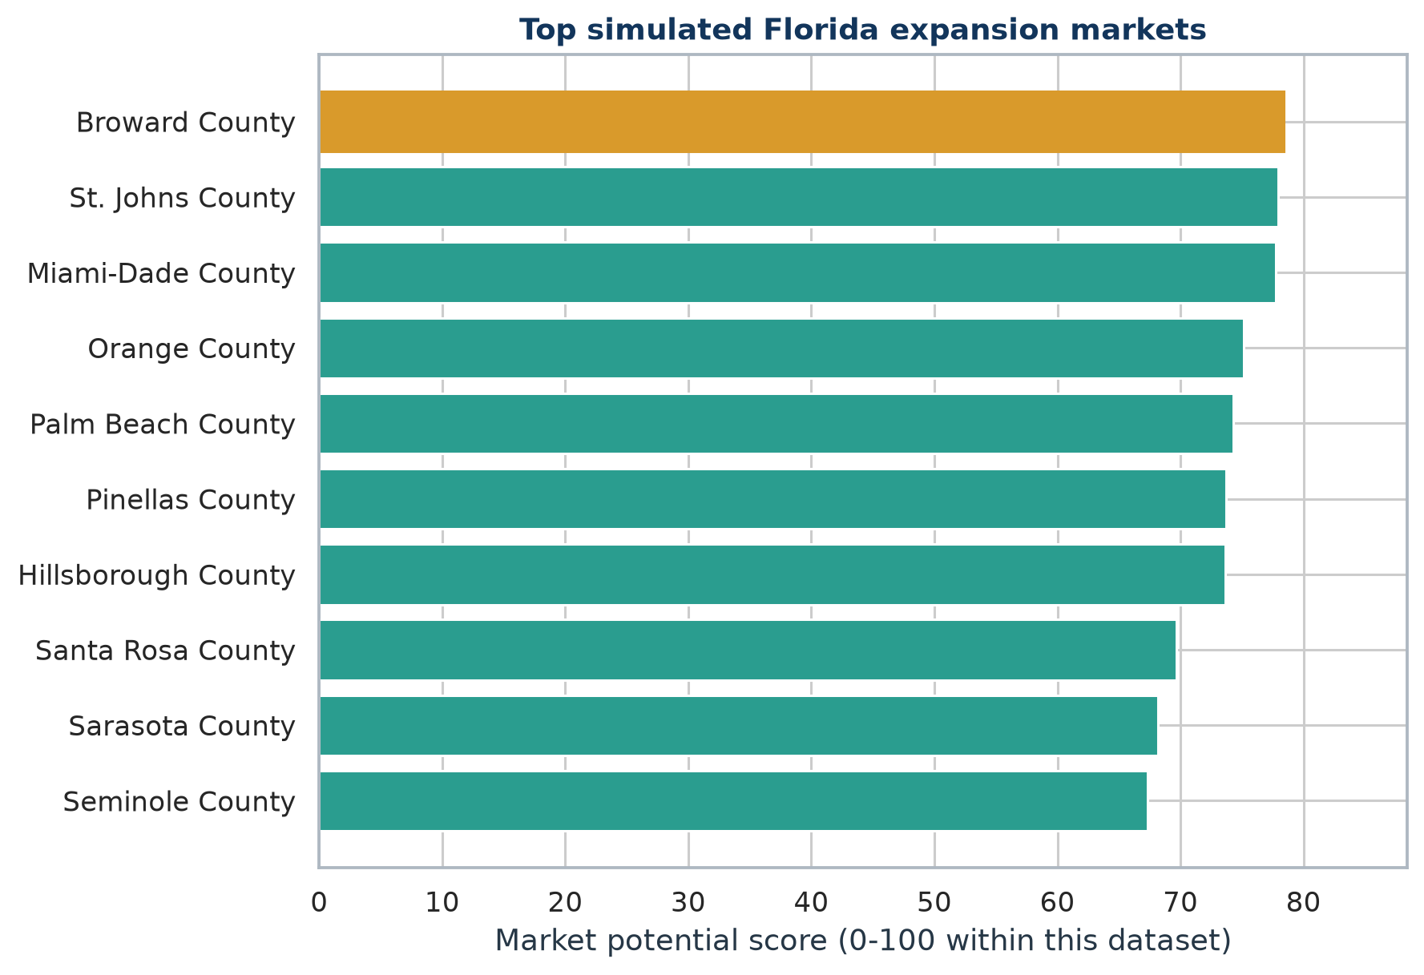
Figure 5. Top ten Florida counties by the simulated market-potential score.

1. Broward County
Score 78.4/100. Key screening strengths: large demand base, favorable tracked-competitor intensity, LA Fitness whitespace. Observed LA Fitness locations: 13; tracked competitors: 27.

2. St. Johns County
Score 77.9/100. Key screening strengths: strong purchasing power, favorable tracked-competitor intensity, LA Fitness whitespace. Observed LA Fitness locations: 0; tracked competitors: 4.

3. Miami-Dade County
Score 77.8/100. Key screening strengths: large demand base, favorable tracked-competitor intensity, LA Fitness whitespace. Observed LA Fitness locations: 16; tracked competitors: 29.

4. Orange County
Score 75.1/100. Key screening strengths: large demand base, favorable tracked-competitor intensity, LA Fitness whitespace. Observed LA Fitness locations: 11; tracked competitors: 23.

5. Palm Beach County
Score 74.3/100. Key screening strengths: large demand base, favorable tracked-competitor intensity, LA Fitness whitespace. Observed LA Fitness locations: 10; tracked competitors: 25.

Recommended Next Actions
- Validate current club rosters, closures, and planned openings in the top five counties.
- Collect observed monthly dues, initiation fees, annual fees, and contract terms for a representative sample of clubs.
- Replace county boundaries with 10- to 15-minute drive-time trade areas around candidate sites.
- Add lease rates, daytime population, age mix, traffic counts, and competitor square footage before site underwriting.
- Re-estimate the model with observed prices and validate out of sample before using it for capital allocation.

Limitations
- Estimated target: county MembershipPrice is simulated from a disclosed formula and is not independent evidence.
- Search coverage: Google Places Text Search ranks candidates and does not guarantee a complete chain inventory.
- Temporal mismatch: demographics use 2020 population and 2021 income, while locations are a 2026 retrieval snapshot.
- Aggregation: county averages mask neighborhood trade areas and cross-county customer travel.
- Small sample: 67 counties limit model complexity and make influential observations consequential.
- Association only: OLS coefficients do not identify causal effects on pricing or expansion success.
- Ranking sensitivity: market-potential results depend on subjective weights and min-max scaling.

Reproducibility and Deliverables
- fitness_market_analysis.py: API collection, integration, EDA, regression, diagnostics, predictions, and rankings.
- build_reports.py: deterministic Word report generation from the analytical outputs.
- data/MainDataset.csv: 67 rows and 8 required columns.
- outputs/: model tables, diagnostic tables, scenario predictions, rankings, and figures.
- API key files are read locally and intentionally excluded from every analytical output.

References
U.S. Census Bureau. 2020 Census Redistricting Data, Table P1, variable P1_001N. Source
U.S. Census Bureau. 2021 ACS 5-Year Estimates, Table B19013, median household income. Source
U.S. Census Bureau. 2020 Gazetteer Files and record layout. Source
Google Maps Platform. Text Search (New) documentation and pagination requirements. Source
LA Fitness. Public online membership rate example with monthly plan options. Source
Planet Fitness. Official membership page with starting monthly rates. Source
Health & Fitness Association. U.S. facility membership and average-dues overview. Source

